Newsletter November 2015
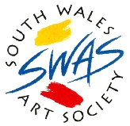

As always, we begin by extending a very warm welcome to all our new members

MARGARET PYKE

Dear Member,
It is with extreme sadness we received the news our Vice President, Margaret Pyke, had passed away. She was a long serving member of the Society who had always offered her services with great enthusiasm with talks on art history, a subject on which she excelled, critiques and sometimes judging our Annual Exhibitions. Two years ago we asked her to become our Vice President, a position she held until she became ill. She was a well loved lady who will be sadly missed by everyone..

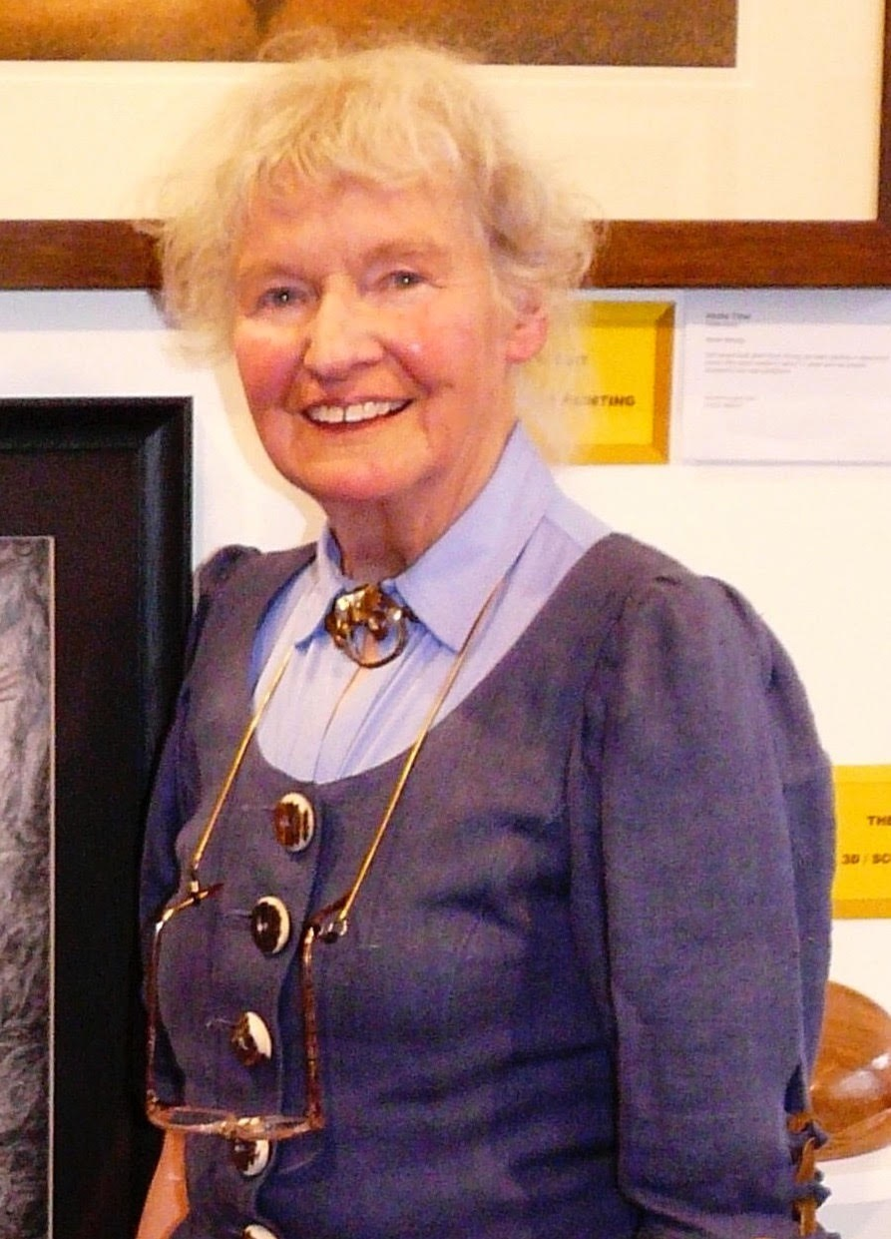

One of the highlights of the SWAS calendar is our Annual Exhibition. As always, it is open to all members who wish to submit works for selection. Please see below for details of the Exhibition, Judging, Rules and Criteria for any members wishing to enter their work(s). Entry Forms will be available in the coming weeks

S W A S Monday Painters.
Front Hall

Thanks to the hard work of Bill Barry, the Monday Painters has gone from strength to strength this year and has seen its numbers grow. It is an ideal opportunity for members to get together in a light-hearted and informal setting, exchange ideas and socialise whilst working on their latest projects. Indeed, it has been so successful that the sessions have been extended into December - Monday 7th & Monday 21st - with a Christmas Party on the 21st. Each season runs from 6-9pm. Listed below are the dates for 2016 and 2017 and cost just £1.50 on the door, which includes free tea, coffee and biscuits. If you are interested in coming along to one of these sessions or would like further information, please speak to Bill Barry

Dates for 2016

March 7th 21st
April 4th 18th
May 2nd 16th 30th
June 6th 20th
July 4th 18th
August 1st 15th 29th
September 5th 19th
October 3rd 17th 31st
November 7th 21st
December 5th 19th

Dates for 2017

January 2nd 16th 30th
February 6th 20th
March 6th 20th

Some Dates for Your Calendar
10 November Critique - Rob McPartland
24 November Demo - Jon Davies

SWAS Christmas Social - 08 December
This is always an excellent opportunity for newer members to come along and join in an evening of light-hearted fun and entertainment. Everyone is welcome. We would like you to bring some food, there will be FREE wine and soft drinks. We shall have our usual quiz, an art competition, with big prizes! Plenty of raffle prizes and an auction of two beautiful easels kindly donated to the Society by Arnold Lowrey, all proceeds of the evening will be donated to our own Charity, Velindre Hospital. We hope to invite a few of their members along for the evening.
Please come, bring your spouse and enjoy yourself. We look forward to seeing you there.

Derek Turner Competition 2016
16 February - “Welsh Landscape”
01 March - “Paraphenalia”

Coach Trips in 2016

Springtime London Exhibition Coach Trip
A visit to two London Exhibitions has been arranged, ‘The Royal Institute of Painters in Watercolour’ at the Mall Gallery and the ‘The Modern Garden - Monet to Matisse’ at the Royal Academy.
The trip will take place on Saturday 8th April 2016.
We have booked a 50 seat coach. We will take provisional bookings. No deposit
required at this time.

Summer Coach Trip to France 2016
We are arranging a continental coach trip this summer, probably in early June.
Exactly the same as was arranged three years ago.
Friday - Depart Cardiff 0630, arrived Rouen, 4pm
Saturday - A visit to Hornfleur for the day
Sunday - A visit to Monet’s Garden at Giverny
Monday - Return journey to Cardiff 6 30 arrival
The cost then was £185.00 for the four nights with breakfast. We are currently
awaiting confirmation of the cost for next year, but imagine it will be around £210.00 and . We are awaiting the to confirm dates to coincide with when the water lilies bloom. If you are interested in going on any of these trips, please speak to Tony Batey

And finally…

Subscriptions for 2016
We would like to remind members that SWAS Annual Subscriptions are due for
renewal on 1st January 2016. For the third year in succession we have held the payment at £35.00. We would respectfully request that members renew promptly to show their support and approval of the effort being made to keep the payments at an acceptable level.

