Newsletter May 2017

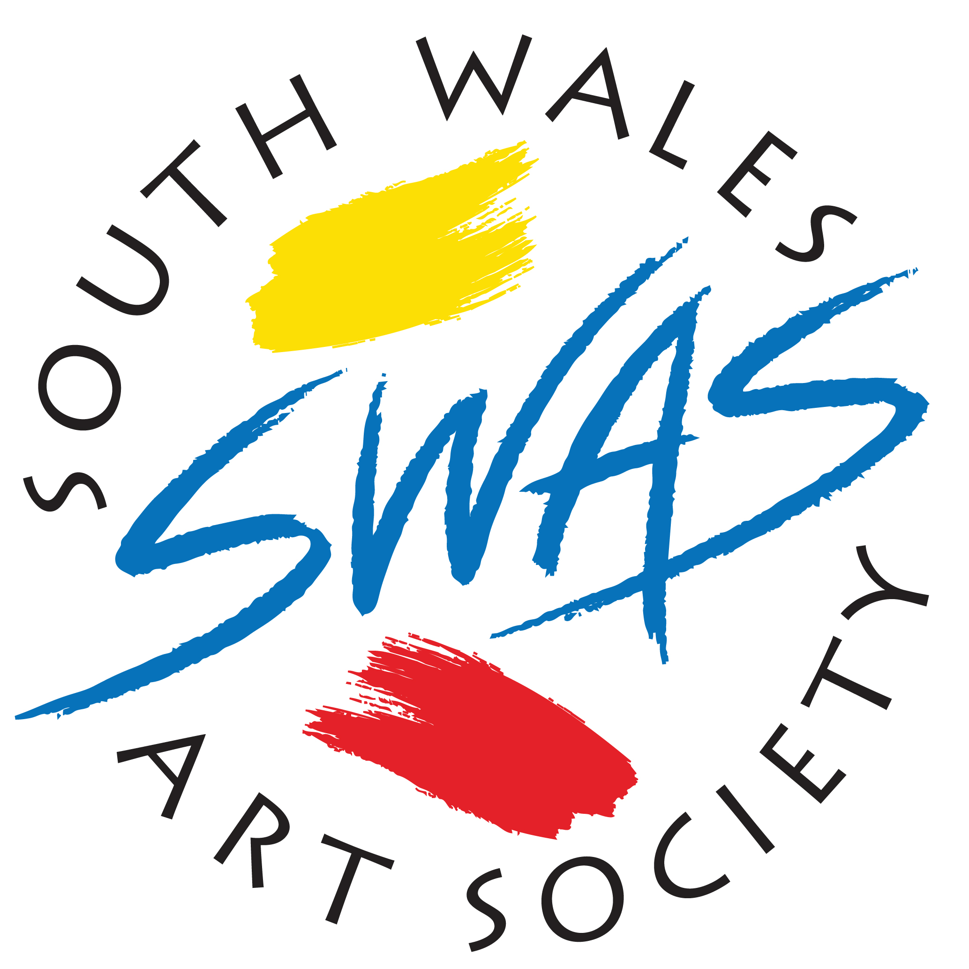

As always we begin by extending a very warm welcome to all our new members. We have a very busy programme of events in the coming months.
Dates for your diary….

Annual Exhibition 2017.
Every year, the Committee works tirelessly to organise what is, undoubtedly, the highlight of the SWAS calendar and this year is no exception. However, despite extensive enquiries over many months to secure a venue to stage this year’s Exhibition, no suitable venue with availability could be found.

However, at the A.G.M on 14th March 2017, a proposal was put forward that the Society hold an Online Exhibition instead, following all the normal procedures set out in the Constitution: i.e. three independent judges, all categories of work accepted and the presentation of all silverware prizes, including the Anthony Rapport Trophy for the Overall Winner.

This proposal, outlined below, was discussed and unanimously agreed at the Committee Meeting on Tuesday 2nd May:

All members can enter up to three works of any size. Entry fee £2.00 per work.

Images will be displayed on the S W A S website, therefore, it will not be necessary to submit framed work; bare canvasses are acceptable but work on paper must be mounted. You may take your own images before selection but we cannot guarantee the quality of your image if we have to photograph it through glass.

Application forms, on the back page of this newsletter, must be submitted by Friday 1st September 2017.

Selection will take place on Saturday 16th September at the Heath Citizens Hall, King Edward V Drive, Cardiff. Handing in of work 11.30 – 1 pm Judging 1.30 – 3 pm Collection of work 4 pm.

Members will be invited to submit image
es electronically after the selection but those who do not have the facility their work will be photographed by the Society. No work will be rejected- judging will take place only to select the prize winners.

It is hoped the Exhibition will go on line in October.

Monday Painters
This remains very popular with members and continues to go from strength to strength. Held in the building next to the hall where we hold our Tuesday evening meetings, these informal and light hearted sessions are an excellent opportunity for members to get together and socialise whilst working on their latest projects and are also great value for money – just £1.50 for 3 hours (6.00pm-9.00pm) this includes tea, coffee and biscuits. These evenings are open to non members, so why not bring a friend along?

The following dates are booked….

May 15th 29th
June 5th 19th
July 3rd 17th 31st
August 7th 21st
September 4th 18th
October 2nd 16th 30th
November 6th 20th

December 4th 18th

Contact Bill Barry for information 07789 701 884

Royal Academy Summer Exhibition
The Society is organising a coach trip to the R A on Saturday, August 19th.
Coach departs 08.00am Earl Haig Club, ( British Legion), Penlline Road, Whichurch, Cardiff.
Second pick up 8.15am at High Cross, Newport. Jnct 27 M4.
There will be two drop off points, Royal Academy and Trafalgar Square.
Return time and location. 5.30 pm Green Park Tube Station, Piccadilly ( Next to Ritz)
Cost of trip £15.00
For all information please contact Betty swas_bndn@btinternet.com

South Wales Art Society 130th Annual Exhibition
October 2017.

Entry form.

In block Capitals
_____________________________________________________Membership No. Name.
_____________________________________________________Address.
______________________________________________________Tel. email

1 | Picture Title (Not to exceed 30 Characters - including spaces) | Price
 |  | £
 | Medium Category

2 | Picture Title (Not to exceed 30 Characters - including spaces) | Price
 |  | £
 | Medium Category

3 | Picture Title (Not to exceed 30 Characters – (including spaces) | Price
 | Medium Category
 |  | £

Awards will be made in the following categories.
Overall prize winner will be selected from the category award winners.
1. The The Anthony Rapport Trophy Overall Winner | Any medium
2. The ‘Copystat’ Portrait Plate Best Portrait | Any medium
3. Norman & Morag Robinson Prize Best Marine Painting | Any medium
4. The Beryl Saunders Memorial Plate Best Still Life. | Any medium
5. The Landscape Prize Best Landscape | Any medium
6. The Figurative Prize Best Figurative. | Any medium
7 The Rosemary Bramley Cup Best line drawing or line and wash  8. The Lilac Searle Rose Bowl Best Abstract  9. The Anton Kolb Miniature Cup Best Miniature | Any subject  Any Subject  Any Subject

Closing Date for entries. 1st September 2017
Entry forms received after this date will not be accepted

1 | Picture Title (Not to exceed 30 Characters - including spaces) | Price
 |  | £
 | Medium Category

2 | Picture Title (Not to exceed 30 Characters - including spaces) | Price
 |  | £
 | Medium Category

3 | Picture Title (Not to exceed 30 Characters - including spaces) | Price
 |  | £
 | Medium Category

Members may enter up to three works, which may be paintings, sculpture or miniatures
A fee of £3.00 will be payable on every work entered

1 | Picture Title (Not to exceed 30 Characters - including spaces) | Price
 |  | £
 | Medium
2 | Picture Title (Not to exceed 30 Characters - including spaces) | Price
 |  | £
 | Medium

3 | Picture Title (Not to exceed 30 Characters - including spaces) | Price
 |  | £
 | Medium

