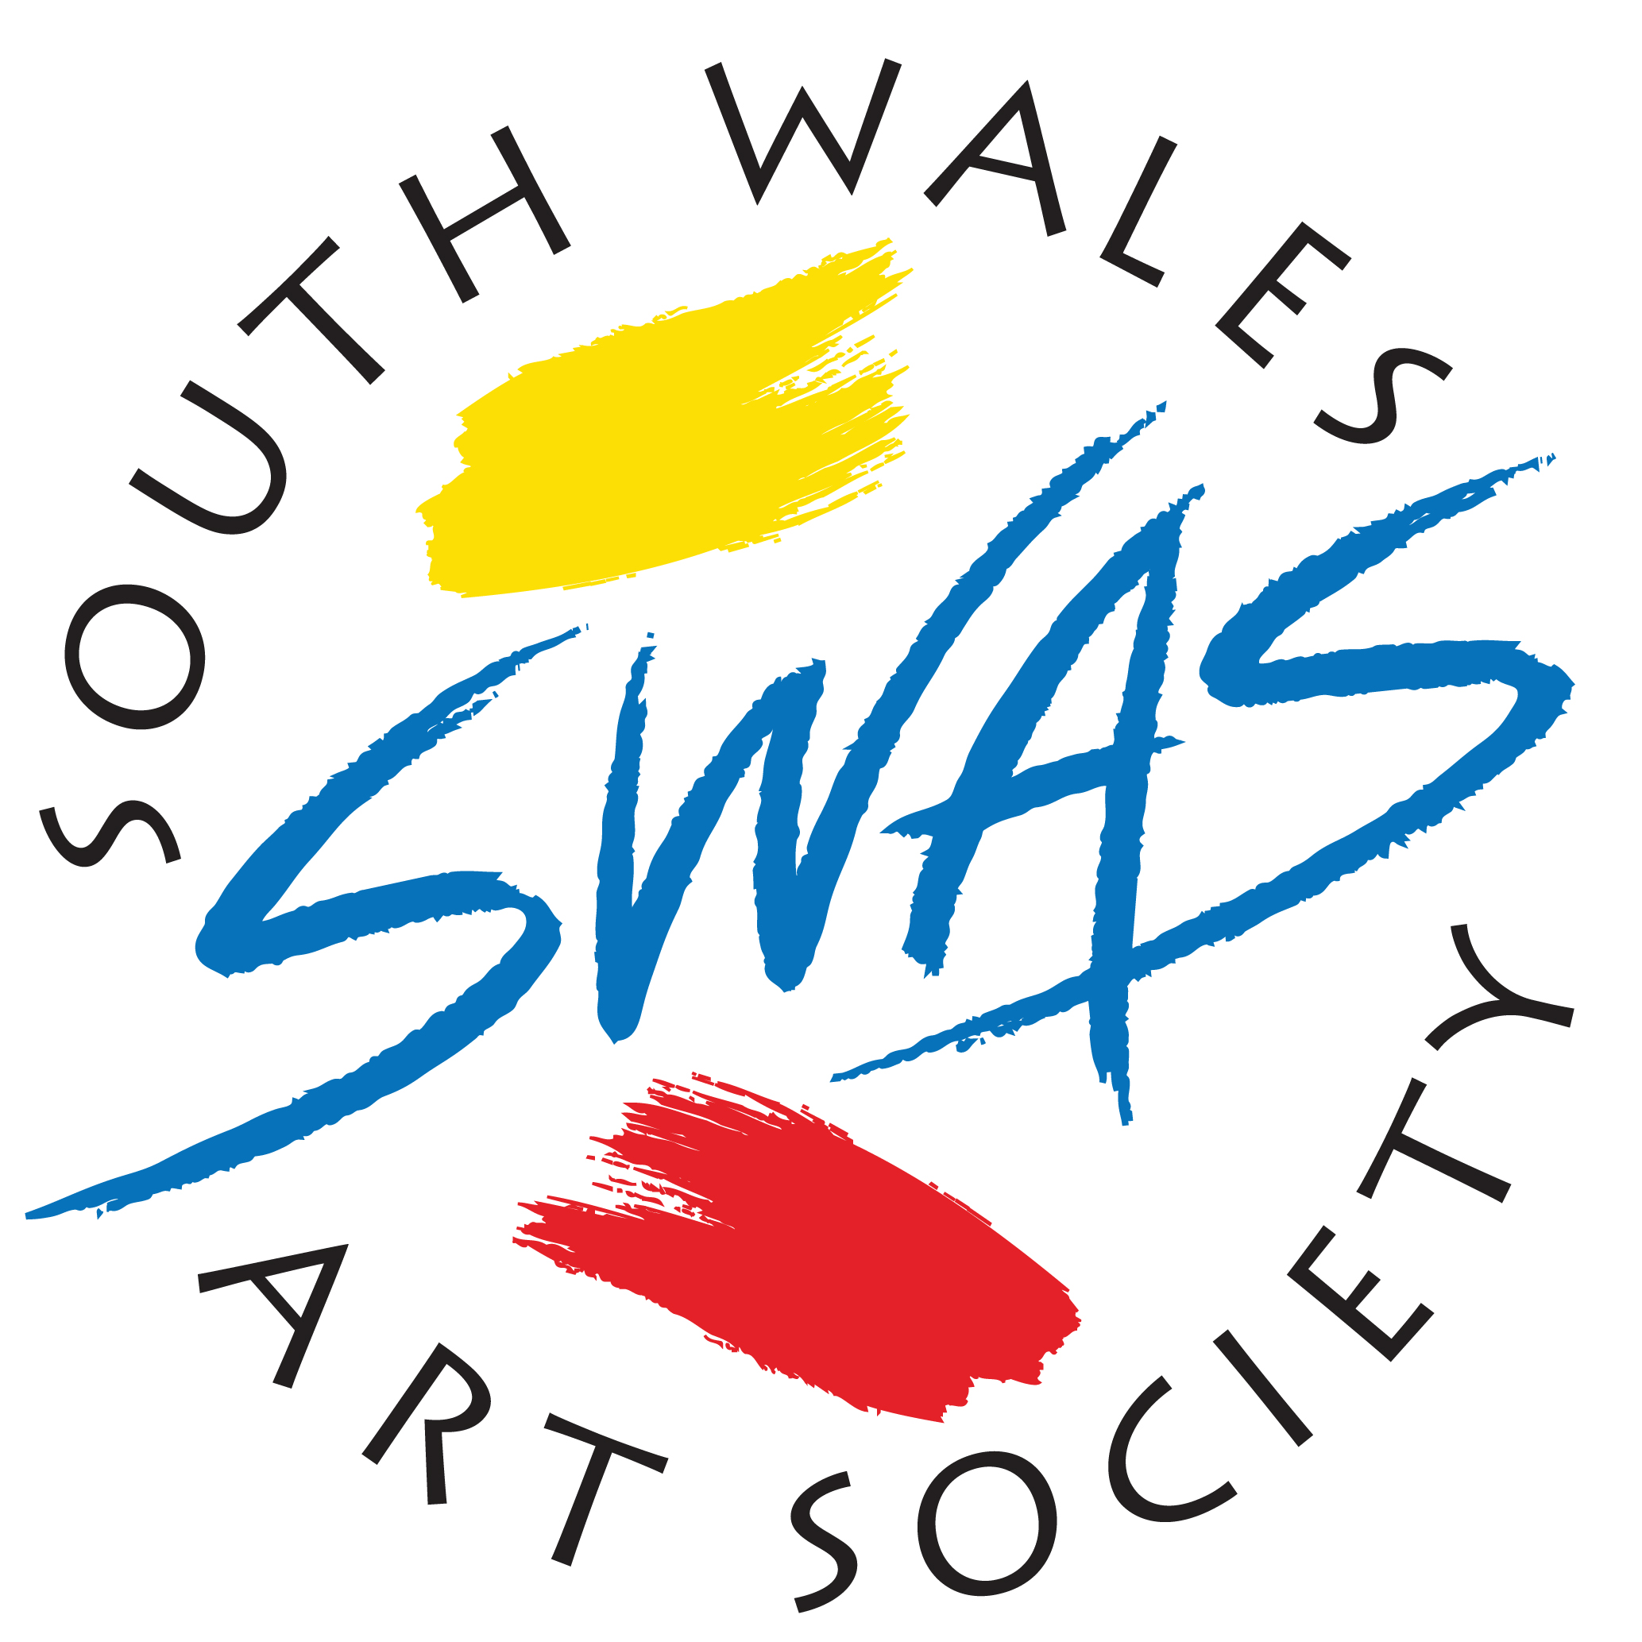 Dear Member,Welcome back & Happy New year.

We have a great Spring programme; a London trip to the David Hockney exhibition,(£14), two competitions, one exhibition and some great demo’s and critiques
January 3rd. Gideon Hall. Critique.
January 17th Jem Bowden. Demo. Watercolour.
January 31st Tim Wilmot. Demo W/c (Sharon Hurst. Cancelled)
February 14th Derrick Turner Competition No1 ‘City Garden’
February 28th Derrick Turner Competition No 2 ‘Contrasts’
This competition is in just 6 weeks, you may interpret the titles as you wish and submit a piece for each category at £2.50 per work
March 14th S.W.A.S A.G.M

March 25th. TRIP TO THE TATE. David Hockney Exhibition.

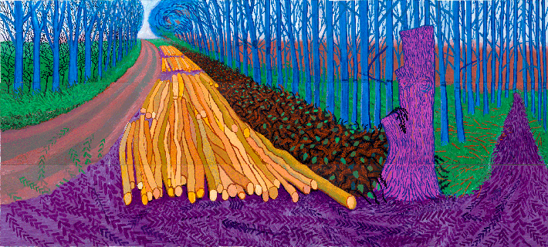

OPEN EXHIBITION at the ‘Gate’ Gallery April 12th to May 5th
Two paintings per member,(£2.50) on a first come first served basis. Please forward. Names initially, Titles & Price to anthonyb919977@gmail.com you will then receive information
(You are allowed to submit your Turner competition pieces ).

MONDAY PAINTERS dates for the New Year.
Jan 2nd, 16th & 30th . Feb. 6th & 20^{th..} Mar 6th & 20th
Bill Barry is the organiser, contact him on 07789 701 884

